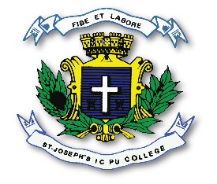
ST. JOSEPH’S INDIAN COMPOSITE PU COLLEGE
#23, Vittal Mallya Road, Bangalore – 560001.

SUBJECT: CHEMISTRY (34)
II PUC
PORTIONS FOR I TEST – 2023-24

TOPICS
SOLUTIONS
D- AND F- BLOCK ELEMENTS
HALOALKANES AND HALOARENES

